Welcome to

Saint-Quay-Portrieux

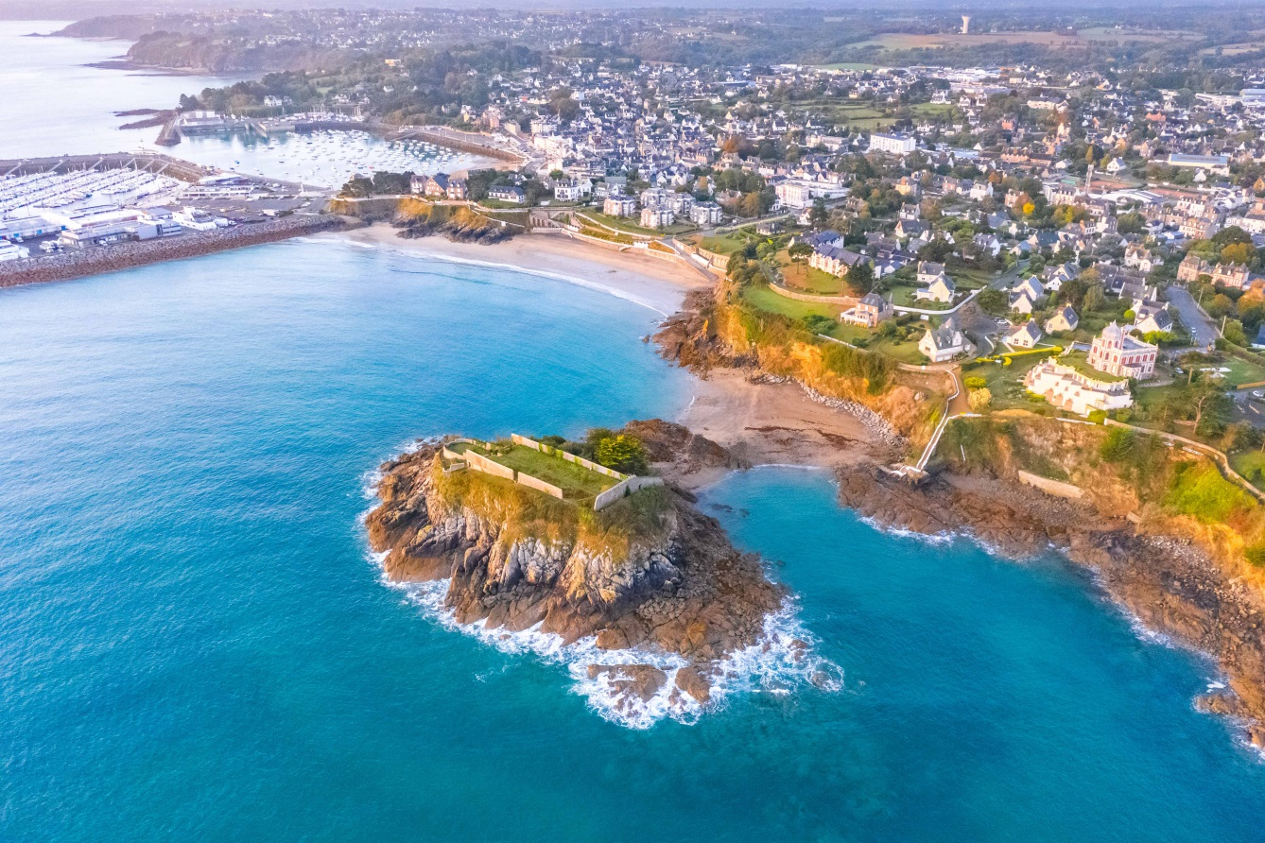

Adresse de votre location + insérer logo label de qualité ou Meublé classé x*

Exemple : Résidence du Port (préciser bâtiment, escalier, étage…)

1 rue des Banches

22410 Saint-Quay-Portrieux

Tél. si existant

Find the exact location on the street map : M13

Mot d’accueil, exemple :

Welcome to our home!

We are delighted that you have chosen to stay with us while you visit Saint-Quay-Portrieux.

In this document you will find all necessary information in order to organise your holidays and discover the region’s charms. Should you require anything else, please do not hesitate to contact us, or the tourist office.

We wish you a pleasant stay.

Contact us:

Vos coordonnées, téléphone, mail et/ ou celles de la personne (ou de l’entreprise – agence ou services) à joindre en cas de problème sur place.

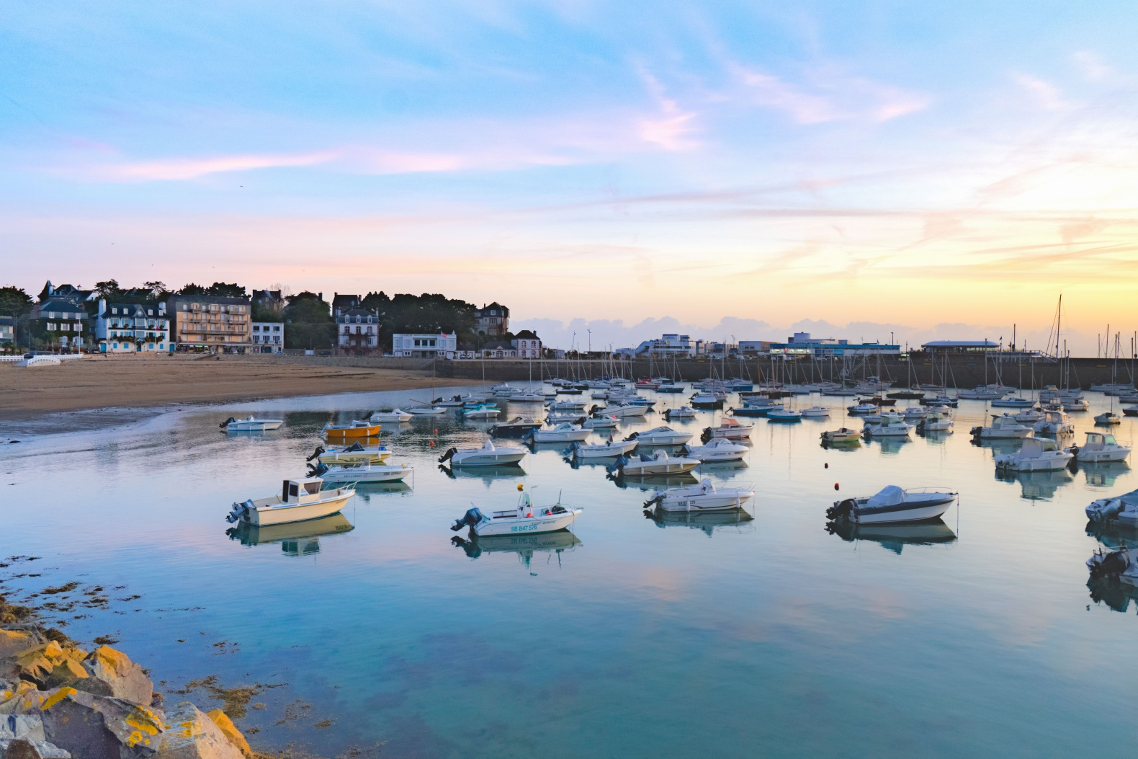

**USEFUL INFORMATION**

Consignes spécifiques pour le logement :

Code d’accès, digicode, accès wifi du logement, clés (noter sur chaque clé : porte d’entrée, porte du garage, du local à vélo …), consigne spécifiques à la résidence…

**Household refuse**: préciser s’il y a un local (et où il est situé) the green (or brown) bin is for household refuse, and the yellow bin (or yellow bags) is for recycling.

Recycling helps reducing the volume of household waste, it is therefore important to do it right. Please refer to pages 7 and 8 of the user guide for more information.

**Appliances:** you will find the appliance instruction manuals on pages 11 and 12.

**Inventory**: complete list of items available on page 6.

**Tourist tax:** information on page 9.

**Label or classification**: Clévacances and Gîte de France on page 10.

**Launderette** : (Si vous n’avez pas de machine à laver) Netto car park - rue Pierre Loti

and Le lavoir des Villages - Esplanade du Port d’Armor.

**EMERGENCY PHONE NUMBERS**

**EUROPEAN EMERGENCY NUMBER: 112**

**EMERGENCY SMS SERVICE FOR DEAF AND HARD OF HEARING PEOPLE: 114**

**24-HOUR EMERGENCY SERVICE: 15**

**POLICE: 17**

**FIRE DEPARTMENT: 18**

**POISON CENTER:** Angers - Tel. +33 (0)2 41 48 21 21

**GENERAL HOSPITAL Y. LE FOLL** 10 rue Marcel Proust, St-Brieuc - Tel. +33 (0)2 96 01 71 23

**EMERGENCY CHEMIST: 32 37**

**POLICE STATION :**

Étables-sur-Mer - Tel. +33 (0)2 96 70 61 24 - 2 rue Charles Le Goffic 22680 Binic-Etables-sur-Mer

**AID STATION PLAGE DU CASINO (July/August)** Tel. +33 (0)2 96 70 30 92

**AID STATION PLAGE DE LA COMTESSE (July/August)** Tel. +33 (0)2 96 70 59 57

**EMERGENCY SERVICE AT SEA:** **196**

**Health services in Saint-Quay-Portrieux**

**NURSES**

CABINET LE PUIL - PIERRE - HOURON - CORQUETEAU - DUVAL - 46 quai de la République - Tel. +33 (0)2 96 70 37 46

CABINET HOUARD - DANIEL – GOURIOU – LE GALL - 89 boulevard Foch - Tel. +33 (0)2 96 70 47 82

**PHYSIOTHERAPISTS**

CABINET BERROCHE - TRANCHEVENT - 6 rue de la Comtesse - Tel. +33 (0)2 96 61 98 51

CABINET PENVERN - 3 rue Adjudant-Chef Cadot - Tel. +33 (0)2 96 70 92 56

CABINET HÉRY - 46 quai de la République - Tel. +33 (0)2 96 70 42 49

**MEDICAL LABORATORY**

CERBALLIANCE - Allée Paul Vatine - Étables-sur-Mer - Tel. +33 (0)2 96 70 86 19

**DOCTORS (GP)**

Centre de santÉ – Résidence des Mimosas 11 rue des Ecoles – Tel. +33 (0)2 96 70 70 80

**OPHTALMOLOGY - HOMEOPATHY**

DR CARRÉ - 24 rue Jeanne d’Arc - Tel. +33 (0)2 96 65 25 05

**OPTICIAN**

SAINT-QUAY OPTIQUE - 14 rue Jeanne d’Arc - Tel. +33 (0)2 96 70 58 82

**ORTHOPTIST**

CABINET COUPIN - 10 rue Jeanne d’Arc - Tel. +33 (0)2 96 70 98 56

**OSTEOPATH**

SYLVAIN LAMOUR - 69 boulevard Foch - Tel. +33 (0)2 96 65 29 73

MARION LE ROLLAND- Résidence Le Mouton Blanc - 52 quai de la République - Tel. +33 (0)2 96 70 33 84

FLORENT GUEGUEN - 3 rue Adjudant-Chef Cadot - Tel. +33 (0)2 96 70 92 56

**CHEMIST**

PHARMACIE MOLAC - 31 boulevard Foch - Tel. +33 (0)2 96 70 40 25

**MEDICAL TRANSPORT / AMBULANCES**

ALLO TAXI CREPIN - Tel. +33 (0)2 96 22 66 05

ATLAS TAXI – Tel. +33 (0)6 37 10 19 84

PROXI-TRANS AMBULANCE - Tel. +33 (0)2 96 70 67 00

**VETERINARIAN**

CABINET DR CÉCILE CAU & DR DAVID CAU - 17 rue du Calvaire - Tel. +33 (0)2 96 70 39 55

**Banks**

All banks offer ATMs.

BANQUE POPULAIRE DE L’OUEST - 2 boulevard du Général de Gaulle - Tel. +33 (0)2 57 44 03 20

CRÉDIT AGRICOLE - 84 boulevard Foch - Tel. +33 (0)9 72 72 72 72

SOCIÉTÉ GÉNÉRALE - 16 quai de la République -Tel. +33 (0)2 96 70 40 02

**Public and Private Transports / Bike Rental / Car Rental**

**BUS**

BREIZHGO // Tel. +33 (0)2 99 300 300 - [www.breizhgo.bzh](http://www.breizhgo.bzh) - Line 1 – Saint-Brieuc / Paimpol

**TAXIS**

ALLO TAXI CREPIN - Tel. +33 (0)2 96 22 66 05

ATLAS TAXI - Tel. +33 (0)6 37 10 19 84

**BIKE RENTAL**

HÔTEL KER MOOR**** - rue Président Le Sénécal - Tel. +33 (0)2 96 70 52 22

BALADE BIKE – Binic-Etables-sur-Mer – delivery service - Tel. +33 (0) 6 10 80 79 22

**Parking**

All car parks are **free**.

**“Blue Zones”** are designated parking areas where you can park for free, but only for a certain period of time. It is compulsory to display a “parking disc” to show your arrival time – failure to do so may result in a fixed parking fine. These parking discs are available to purchase from the local Tabac or Maison de la Presse for a small fee.

**Administrative services and other services**

**PUBLIC SERVICES**

TOWN HALL - 52 boulevard Foch - Tel. +33 (0)2 96 70 80 80 - www.saintquayportrieux.fr

POST OFFICE - 33 boulevard Foch - Tel. +33 (0)2 96 70 42 63

Closed on Monday, Tuesday: 10 am -12 am/2 pm - 4:45 pm, Wednesday to Friday: 9am – 12 am/2pm - 4:45 pm, mail departure at 3:50 pm - Saturday: 9 am – 12 am, mail collected at 11:50 am - No ATM.

ERDF (Electricity supplier) - Tel. +33 (0)810 81 33 27 - Sécurité - dépannage - Tel. +33 (0)9 72 67 50 22

GRDF (Gas supplier) - Tél. +33 (0)9 69 36 35 34 - Sécurité - dépannage - Tel. +33 (0)800 47 33 33

VEOLIA EAU (Water supplier) - Z.A. de Kertugal - Tel. +33 (0)9 69 32 35 29

**CATHOLIC CULT**

PARISH HOUSE - 12 place de l'Eglise - Étables-sur-Mer - Tel. +33 (0)2 96 70 61 51

Masses at the church of Saint-Quay-Portrieux: on Sundays during summer, at 10:30 am. - The rest of the year: on the 3rd Sunday of the month at 10:30 am. (on the first Sunday of the month in Binic, and on the 2nd and 4th Sundays of the month in Etables-sur-Mer).

**GARAGES**

GARAGE DES ISLANDAIS -Z.A. des Islandais - Étables-sur-Mer – Tel. +33 (0)2 96 65 20 10

GARAGE PEUGEOT - Z.A. des Islandais - Étables-sur-Mer – Tel. +33 (0)2 96 70 95 88

GARAGE RENAULT - Z.A. des Islandais - Étables-sur-Mer - Tel. +33 (0)2 96 70 90 90

**GAS STATIONS**

MARKET - Boulevard des Islandais – Etables-sur-Mer - Tel. +33 (0)2 96 70 57 44

NETTO – Rue Pierre Loti – St-Quay-Portrieux – Tel. +33 (0)2 96 70 46 24

**GAS BOTTLE RETURN**

MARKET - Boulevard des Islandais – Etables-sur-Mer - Tel. +33 (0)2 96 70 57 44

NETTO – Rue Pierre Loti – St-Quay-Portrieux – Tel. +33 (0)2 96 70 46 24

**WIFI** (@CCES UNDER CONDITIONS)

**BAR RESTAURANT LES COCHONS FLINGUEURS** - Place de la Plage - Tel. +33 (0)2 96 70 73 51

**BAR RESTAURANT LE CAFE DE LA PLAGE** - Place de la Plage - Tel. +33 (0)2 96 33 74 67

**BAR PMU LE MUSTANG -** 30 rue Jeanne d’Arc - Tel. +33 (0)9 61 65 28 91

**BAR L’ÉCUME** - Esplanade du Port d’Armor - Tel. +33 (0)2 96 65 23 08

**BAR LE KREISKER** - 18 rue jeanne d’Arc - Tel. +33 (0)2 96 70 57 84

**BAR LE POISSON ROUGE** - 18 quai de la République - Tel. +33 (0)2 96 70 51 59

**CAPITAINERIE DU PORT D’ARMOR** - Tel. +33 (0)2 96 70 81 30

**KASINO DE SAINT-QUAY** - Boulevard du Général de Gaulle - Tel. +33 (0)2 96 70 40 36

**OFFICE DE TOURISME** - 17 bis rue Jeanne d’Arc - Tel. +33 (0)2 96 70 40 64

**INVENTORY**

🞏 Landlord or 🞎 Proxy: Full name :

Address: ………………………………………………………………………………………………………………………..

Rental location: ………………………………………………………………………………………………………………

**TABLEWARE (1)**

Plates: .…….dinner plates  ……..soup plates  ……..dessert plates

Dishes: …….hors d’œuvre dishes ……..soufflé dishes .…..gratin dishes ……..deep dishes

...….salad bowls ……..soup tureen ……..serving dishes

Cutlery: ……..salad servers ...…..forks ……..skimmer ….. whisk ……..ladle

Spoons:……..soup spoons ……..dessert spoons ……..wooden spoons

Knives: ……..table knives ……..bread knife ……..kitchen knife …….electric carving knife

Pans : ……..pots ……..big pans ……..small pans

Glasses: ……..drinking glasses ……..wineglasses ……..liqueur glasses ……..bowls

Coffee set : …….. cups ……..saucers ……..teaspoons

**KITCHEN UTENSILS (1)**

🞏 frying pan 🞎 sauté pan 🞎 stewpot 🞎 pressure cooker

🞎 coffee grinder 🞎 coffee maker 🞎 salad spinner 🞎 fryer

🞎 colander 🞎 corkscrew 🞎 tin opener 🞎 bottle-opener

🞎 lemon squeezer 🞎 cheese grater 🞎 chopping board 🞎 pepper shaker

🞎 salt shaker 🞎 sugar castor 🞎 table mat 🞎 funnel

🞎 egg cups 🞎 butter dish 🞎 toaster 🞎 measuring jug

🞎 food mill 🞎 baking tin 🞎 teapot 🞎 lids

🞎 breadbasket 🞎 bread bin 🞎 food processor 🞎 other : ………….

**CLEANING TOOLS (1)**

🞎drainer 🞎 basin 🞎 bucket 🞎 broom

🞎 scrubbing brush 🞎 carpet sweeper 🞎 vacuum cleaner 🞎 dustpan

🞎 mop 🞎 bin 🞎 ashtrays 🞎 hangers

🞎 drying rack 🞎 clothes pegs 🞎 clothes brush 🞎 autres

🞎 iron 🞎 ironing board 🞎 ironing board cover

**GARDEN FURNITURE (1)**

🞎 table 🞎 chairs 🞎 sun loungers 🞎 parasol

🞎 swing 🞎 barbecue 🞎 benches 🞎 other : ……

**FIREPLACE ACCESSORIES AND TOOLS (1)**

🞎 tongs 🞎 blower 🞎 fireplace screen 🞎 brush 🞎 spade 🞎 andirons

**HOUSEHOLD LINEN (1)**

Tableclothes: ………. tea towels : …….. napkins: ………

Blankets: ………… duvets: …….. bedspread: ……………….

Pillow: ……… Bolsters: …………… sheets: ………….

Mattresse protectors: ……….. pillowcases : …………. Bolstercases:…..

Flannels: …… towels : ……… large towels:………

**DECORATIVE OBJECTS (1)**

🞎 clock……. 🞎 mirror…….. 🞎 paintings…….. 🞎 vases……..

**OTHER : :**______________________________________________________________________

Date : / /

Name of landlord(or proxi) and signature Name of guest and signature

**The inventory must be done before checking-in and before checking-out**

1. Tick the box and/or indicate the number of items

Tourist tax (taxe de séjour)

**The product of tourist tax (taxe de séjour) is allocated to the development of tourism. It is collected by rental landlords who then transfer to the city of Saint-Quay-Portrieux. The city will then be able to fund actions to promote tourism.**

**We wish you a pleasant stay.**

🠆 The tourist tax is collected by rental landlords from January 1st to December 31st, from all tourists who spend at least one night on the territory.

🠆 The tourist tax does not apply to:

- Children (under the age of 18)

- Seasonal workers employed in the area

- People in emergency accommodation or temporary housing

- Person occupying premises below an amount determined by City Council (1€)

🠆 France distinguishes accommodation that has a tourist certificate classification and accommodation that either does not have any classification, or that is waiting to be classified, and the rates of tourist tax differ accordingly.

|  |  |
| --- | --- |
| **Category of accomodation** | **Nightly cost per person** |
| Luxury establishments higher than 5-star rating | 4,40 € |
| 5-star hotels, 5-star tourist residences, 5-star furnished self-catered or catered accommodation | 2,20 € |
| 4-star hotels, 4-star tourist residences, 4-star furnished self-catered or catered accommodation | 1,65 € |
| 3-star hotels, 3-star tourist residences, 3-star furnished self-catered or catered accommodation | 1,32 € |
| 2-star hotels, 2-star tourist residences, 2-star furnished self-catered or catered accommodation, 4-star and 5-star holiday villages and equivalent | 1,10 € |
| 1-star hotels, 1-star tourist residences, 1-star furnished self-catered or catered accommodation, 3-star, 2-star, and 1-star holiday villages, B&B | 0,88 € |
| 5-star, 4-star, and 3-star open-air accommodation (campsites, camping car pitches, 24-hour tourist parking, and equivalent) | 0,66 € |
| 2-star, and 1-star open-air accommodation (campsites, camping car pitches, 24-hour tourist parking, and equivalent), boating marinas | 0,22 € |
| **Accomodation** | **Rate** |
| Accomodation pending classification, or without any classification, except for open-air accomodation | 5,00% |
| *The rate of the tourist tax may not exceed 4 euros per night The tax is calculated only on the price of the rent excluding tax* | |

🡺 The local taxes are governed by articles L.2333-26 à L.2333-46 of the Code Général des

Collectivités Territoriales

🡺 For more information, contact the Tourist Office at +33 (0)2 96 70 40 64.

**Décision de classement ou certificat d’agrément ou les 2**

Appliance instruction manuals

**(Glisser les notices ou créer des notices simplifiées)**

Appliance instruction manuals

**(Glisser les notices ou créer des notices simplifiées)**

**TOURIST INFORMATION**

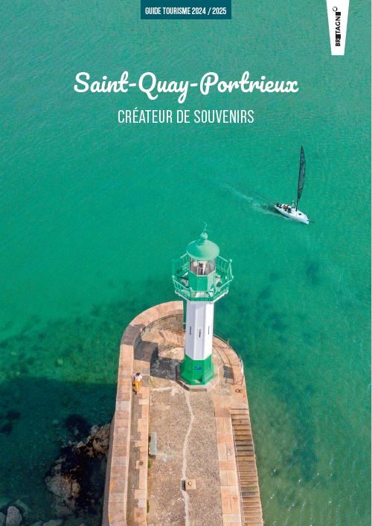

Classified as a seaside resort in 1921 and climatic in 1930, Saint-Quay-Portrieux is a charming seaside resort.

The Portrieux, and its alleys shaped by the history of fishing in Newfoundland, combines harmoniously with the Port d'Armor, a popular marina and 5th French fishing port (1st Breton port for the scallop).

At the foot of the customs path, highlighted by their white balcony, the beaches with memories of the first sea baths are discovered and come alive with a thousand colors. On the cliff or nestled in the heart of the city, the most audacious villas between avant-gardism, modernism and Belle Époque will surprise you.

Find in the Holliday Guide and the documentation at your disposal all the ingredients for a great vacation.

✔ The beaches, the seawater pool and the paddling pools

✔ Leisure activities, a multiple and varied choice:

Nautical activities, cruises, fishing, hiking, tennis, horseback riding, golf, archery, table tennis, cinema, night club, casino, library, mini-golf ...

✔ Activities all year round: for young and old. Detailed programs in Le Phare (monthly publication), the program for the short school vacations and the summer program.

✔ Exceptional natural sites: the Pointe du Sémaphore, the GR 34, the Pointe du Bec de Vir in Tréveneuc.

✔ The unmissable

The island of Bréhat

Circuit of the cliffs of Plouha (the highest cliffs of Brittany!)

Zooparc of Trégomeur

Castle and gardens of La Roche Jagu

The small cities of character of Châtelaudren and Pontrieux

The Abbey of Beauport in Paimpol

... and a little further on the Pink Granite Coast, the Talbert furrow, the Castel Meur chasm, the Erquy and Fréhel capes, Fort Lalatte, the Guerlédan lake, medieval towns, castles, parks...

Getting around

on foot, by bike or by bus





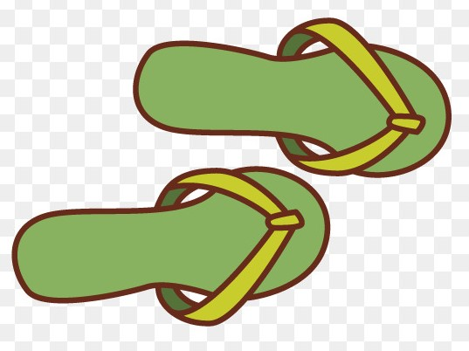

Port d’Armor

Chapelle Sainte-Anne

Drying harbour, Monday market,

Quai Robert Richet

Sémaphore

Plage de la Comtesse and Island

Cinéma Arletty

Plage du Casino and

outdoor seawater pool

Church, Friday market

Moulin Saint-Michel

Kertugal and chapelle

Notre Dame de la garde

Tide tables

Glisser l’annuaire des marées ou une copie du mois en cours.

** The local markets in Côtes d’Armor** 

**All year long … in the morning (with some exceptions)**

**Monday**: Châtelaudren, Pontrieux, **Saint-Quay-Portrieux (port)**, Trégastel

**Tuesday**: Belle-Isle-en-Terre (4 pm-6:30 pm), Bourbriac, **Étables-sur-Mer**, Fréhel, Lancieux, Louannec, Moncontour (4:30 pm - 7:30 pm), Pabu (organic food, 4 pm-7 pm), Paimpol, Pléneuf-Val-André, Pleudihen-sur-Rance, Plouaret, Plouasne, Ploulec’h (4 pm-8 pm), Quintin, Rostrenen, Saint-Cast-le-Guildo, Trébeurden, Trévou-Tréguignec

**Wednesday**: Broons, Callac, L’île Grande (Pleumeur-Bodou), Matignon, Merdrignac, Perros-Guirec (port), **Plouha**, Ploumagoar (4 pm-7 pm), Saint-Brieuc, Saint-Donan, Tréguier

**Thursday**: **Binic**, Dinan, Goudelin (4:30 pm-7:30 pm), Lamballe, Lannion (all day long - food only in the morning), Louargat, Ploeuc-L’Hermitage (Ploeuc-sur-Lié)

**Friday**: Bégard, Caulnes, Corlay, Guerlédan (Mûr-de-Bretagne, 4:30 pm-8 pm), Guingamp, Jugon-les-Lacs, La Roche-Derrien, Lanrodec (1 Friday out of 2 - odd week- 4 pm-7 pm), Lanvollon, Lézardrieux, Loguivy-Plougras, Pabu ((organic food, 4 pm-7 pm), Perros-Guirec (downtown), Plaintel, Plélo, Pléneuf-Val-André, Plérin (4:30-8 pm), Pleslin-Trigavou, Ploubalay, Ploufragan, Pordic, Saint-Cast-le-Guildo, Saint-Jacut-de-la-mer, **Saint-Quay-Portrieux (église)**, Trégueux (organic food, 4 pm-8 pm)

**Saturday**: Dolo, Erquy, Evran, Guingamp, Lannion, Léhon (Dinan), Le Vieux Marché (organic food), Loudéac, Penvénan, Plancoët, Plédran, Pléneuf-Val-André (Dahouët), Pleubian, Pleudaniel, Pleumeur-Bodou, Plouézec, Ploumillau, Quintin (organic food), **Saint-Brieuc**, Saint-Hélen,

**Sunday**: **Étables-sur-Mer**, Lannion, Languenan, Lanvallay, Perros-Guirec (La Clarté), Plérin, Plestin-les-Grèves, Ploubazlanec, Plouër-sur-Rance, Quessoy, Saint-Brieuc (Croix Saint-Lambert), Yffiniac

**Only during Summer (July, August) … in the morning (with some exceptions)**

**Monday:** Erquy (from July 10th to August 21st - 5 pm-9 pm), Penvénan (Buguélès - from 6 pm), Saint-Cast-le-Guildo

**Tuesday**: Hillion (6:30 pm-9:30 pm), Perros-Guirec (Ploumanac’h - from June to September), Pléhérel-Plage (July 11th to August 22nd), Plestin-les-Grèves (from July 21st to August 11th - from 7 pm), Plorec-sur-Arguenon (from July 11th to August 15th), Pommerit-Le-Vicomte (from april to october, 5 pm-8 pm)

**Wednesday**: Saint-Méloir des Bois (5 pm-9 pm), Pleslin-Trigavou

**Thursday:** Penvénan (Port Blanc), Plouguiel, Plouha (from July 20th to August 17th from 7 pm), Saint-Cast-le-Guildo (5 pm-10 pm), Plerneuf (from 4 pm), Pléven (5 pm-8 pm), Tréméven (5 pm-8 pm)

**Friday**: Broons (6:30 pm-8 pm),Créhen (5 pm-8 pm),Mur de Bretagne (4 pm-9 pm), Plélan-le-Petit (4 pm-9 pm), Plérin (les Rosaires, 5 pm-9 pm), Plurien, Trébeurden (5 pm-8 pm)

**Sunday**: Bon-Repos-sur-Blavet (from april to october, 10 am-1 pm), Dinan, Plougrescant (from June 18th to September 17th), Sable d’Or les Pins (from June 25th to August 27th), Saint-Alban (from April 16th to September 3rd), Trélévern (from June 4th to September 24th)

  

**Restaurants**

**ATYPIC** – Esplanade du Port d’Armor – Tel. +33 (0)2 96 62 82 68 – Regional cuisine / Giant skewers

**BOUILLON PARADIS** – 17 rue Georges Clemenceau – Tel. +33 (0)2 96 62 82 68 – World cuisine / Local products

**CRÊPERIE DU PORT** – 50 quai de la République – Tel. +33 (0)2 96 70 40 04 – Creperie / Salads, salted pies / Tea room

**LA BIENVENUE**– 2 place du Centre – Tel. +33 (0)9 80 48 60 08 – Street food : sunny pocket

**LA COQUILLE** – 72 boulevard Foch – Tel. +33 (0)2 90 03 67 83 – Régional cuisine / Local products

**LA P’TITE CRÊPERIE** – 9 rue du Commandant Malbert –Tel. +33 (0)2 96 70 31 55 - Creperie

**L’ESCABELLE** – 7 rue de Dol – Tel. +33 (0)2 96 70 47 55 – Creperie and regional cuisine

**LE CATAMARAN / LE PESKINO** -Esplanade du Port d’Armor - Tel. +33 (0)2 52 70 04 22 – Fish and seafood

**LA CACHETTE** – 21 rue Georges Clemenceau - Tel. +33 (0)2 96 33 41 55 – World cuisine

**LA MARINE** – 38 quai de la République - Tel. +33 (0)2 96 42 65 68 – Local products

**LE CAFÉ DE LA PLAGE** - 3 place de la Plage - Tel. +33 (0)2 96 70 56 91 – Regional cuisine, seafood

**LE POISSON ROUGE** – 18 quai de la République – Tel. +33 (0)2 96 70 51 59 – Creperie

**LE P’TIT FLOT** – 19 rue Georges Clemenceau – Tel. +33 (0)2 96 72 26 12 – Regional cuisine / Pizzeria

**LE SUN 7 –** 20 rue Jeanne d’arc - Snack

**LE TARTAN** – 3 place Saint-Roch – Tel. +33 (0)2 96 65 29 72 – Pizzeria / Regional cuisine, grilled on a wood fire

**LE VICTORIA** – Esplanade du Port d’Armor – Tel. +33 (0)2 96 65 20 77 – Regional cuisine / Seafood / Pizza

**LES COCHONS FLINGUEURS** – Place de la Plage – Tel. +33 (0)2 96 70 73 51 – Regional cuisine / Creperie / Salads

**LES ENFANTS TERRIBLES** – 3 rue du Commandant Malbert – Tel. +33 (0)2 96 68 93 83 – Regional cuisine / Pizzeria / Daily menu

**LES PLAISANCIERS** – Esplanade du Port d’Armor – Tel. +33 (0)2 96 70 49 21 – Regional cuisine / Worker’s menu / Glacier

**LES TERRASSES DU PORT** – Esplanade du Port d’Armor – Tel. +33 (0)2 96 72 23 03 – Regional cuisine

**QUAY 911** – Esplanade du Port d’Armor – Tel. +33 (0)2 96 65 23 60 – Regional cuisine / Fish and seafood

**RESTAURANT DU KASINO** – 6 boulevard Général de Gaulle – Tel. +33 (0)2 96 70 40 36 – Regional cuisine

**TREDICI** – 13 rue Jeanne d’Arc – Tel. +33 (0)2 90 90 16 25 – Pizzas to take-away

**Nearby :**

In Etables-sur-Mer

**VIA COSTA** – Plage du Moulin – Tel. +33 (0)2 96 70 79 57 – World cuisine / Seafood / Pizzeria

In Tréveneuc

**LE CRAPAUD ROUGE** – Plage de Port Goret – Tel. +33 (0)2 96 70 36 21 – Mussels / Open from April to September

**LES VIVIERS SAINT-MARC** – Grève Saint-Marc – Tel. +33 (0)2 96 70 56 30 – Seafood / Mussels / Open from April to September

**TOURIST INFORMATION / vos suggestions**

**TOURIST INFORMATION**